**NAME: Ahmed, Abir  
ID: 18-38824-3  
  
  
Class Diagram :**

|  |
| --- |
| Manager |
| -Name: string -DOB: date -ID: int -Phone Num: int |
| +getName(): string +getDOB(): date +getID(): int +getPhoneNum():int +setName(string) |

|  |
| --- |
| Admin |
| -Name: string -DOB: date -ID: int -Phone Num: int |
| +gerName(): string +getDOB(): date +getID(): int +getPhoneNum(): int +setName(string) |

|  |
| --- |
| Customer |
| -name: string  -Phone Num: int -Address: string |
| +getName(): string +getPhoneNum(): int +getAddress(): string +setName(string) |

|  |
| --- |
| Order |
| -OderID: int -TableID: int -Quantity: int -Item: string -Amount: int |
| +getOrderID(): int +getTableID(): int +getQuantity(): int +getItem(): string +getAmount(): int |

|  |
| --- |
| Inventory |
| -ingredientsName: string -ingredientsID: int -ingredientsQuantity: int |
| +getIngredientsName(): string +getIngredientsID(): int +getIngredientsQuantity(): int |

|  |
| --- |
| Payment |
| -PaymentID: int -PaymentType: string Amount: int |
| +getPaymentID(): int +getPaymentType(): string +getAmount(): int |

|  |
| --- |
| Menu |
| -FoodName: string  -FoodID: int -FoodPrice: int |
| +getFoodName(): string +getFoodID(): int +getFoodPrice(): int |

**Database Schema:**

|  |
| --- |
| Admin |
| Name string DOB date ID int Phone Num int |

|  |
| --- |
| Customer |
| Name string Phone Num int Address string |

|  |
| --- |
| Manager |
| Name string DOB date ID int Phone Num int |

|  |
| --- |
| Order |
| OrderID int TableID int Quantity int Item string Amout int |

|  |
| --- |
| Inventory |
| ingredientsName string ingredientsID int ingredientsQuantity int |

|  |
| --- |
| Payment |
| PaymentID int PaymentType string Amount int |

|  |
| --- |
| Menu |
| FoodName string FoodID int FoodPrice int |

**UI Mockups:**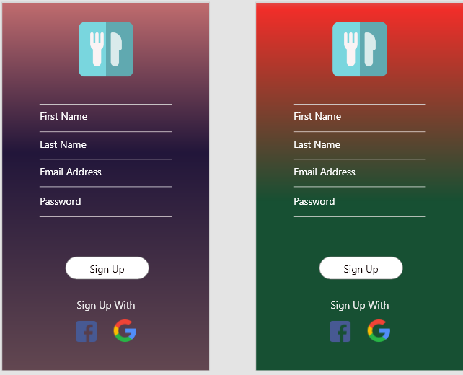

**Activity Diagram :**